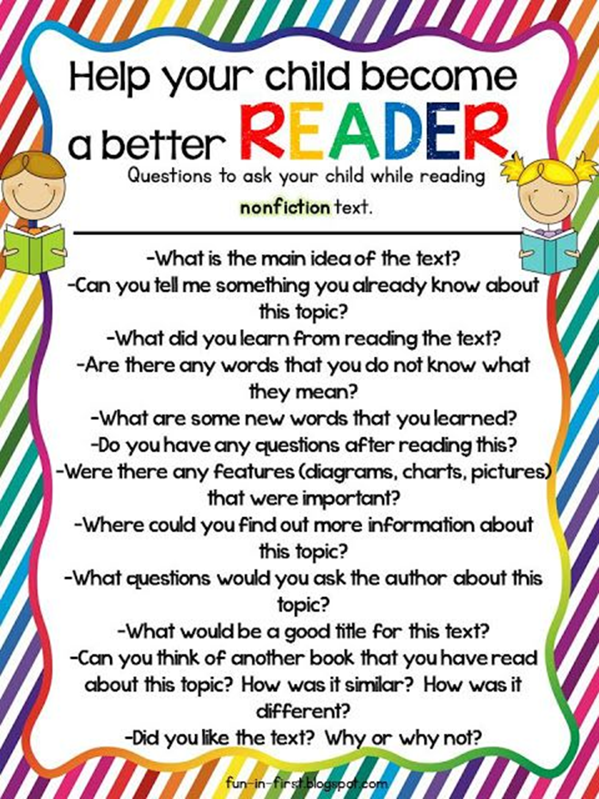**[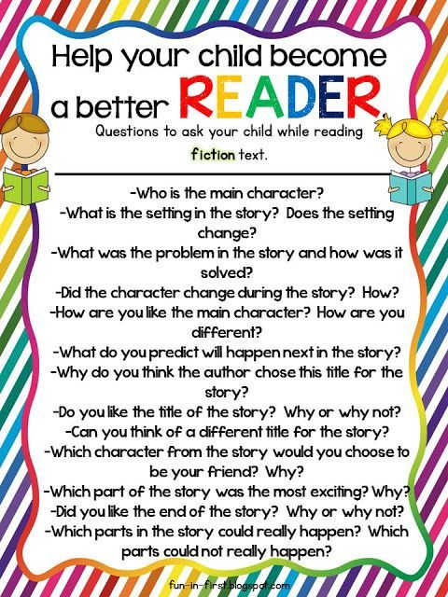](http://justreed-ashley.blogspot.com/2013/07/wrapping-up-ten-pin-summer-linky-back.html)**